Developing inquiry questions
Note: These skills will be used later when you are working on your inquiry assessment task.

It is important when researching to have a set of questions to frame your task.
These are called inquiry questions.

Inquiry questions can be created by breaking down the key words in the main question.

Step 1: Highlighting key words
Key words are words that are important to the question/topic. They may be geography-specific words or words with specific directions (like reduce, impact, effect of).

For example: “Has the creation of national parks in Australia been positive or negative?”

The next step is to develop questions around these key words.

If you can develop questions using all of these you can be more confident to cover all areas in your research. Your questions should use the keywords.

Step 2: Developing questions
Create sub questions starting with: Who, what, why, when, where, how
For example: Who benefits from a national park? What is a national park?

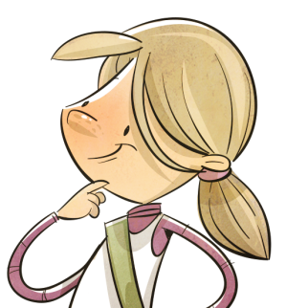
These questions will help you know what you need to research. However, you may not research them in that order.

Step 3: Ordering questions
Think about which questions are the best to ask first.
Rearrange your questions.

For example: it might be better to research ‘What is a national park?’ before asking ‘Who benefits from a national park?’

Inquiry question:

Has the creation of national parks in Australia been positive or negative?

Step 1: Highlight any keywords or phrases in the inquiry question above.

Step 2: Develop a list of sub-questions that use the keywords and break the inquiry question down into smaller questions.

- ______________________________________________________________________
- ______________________________________________________________________
- ______________________________________________________________________
- ______________________________________________________________________
- ______________________________________________________________________
- ______________________________________________________________________
- ______________________________________________________________________
- ______________________________________________________________________

Step 3: Rank your questions above (first to last) in the order in which you think you’d investigate them.

- ______________________________________________________________________
- ______________________________________________________________________
- ______________________________________________________________________
- ______________________________________________________________________
- ______________________________________________________________________
- ______________________________________________________________________
- ______________________________________________________________________
- ______________________________________________________________________

Step 4: Gathering information for my research
You may be wondering, “What next? I have my questions.”

Once we have our questions to help us research, we need to gather our information. But there is so much information out there, not all of it useful.

Researching:
The information used to answer your inquiry questions can come from many sources. It could come the internet, a book or from field work (e.g. observations, surveys). Some sources of information are better than others. Which source best answers the inquiry question?

For example:
Inquiry question: “Who benefits from a national park?”

Source 1:
National parks are where animals can be safe.

Source 2:
National parks are places that are environmentally important. They are protected for the enjoyment of future generations, their natural beauty and the plants and animals that live in them.

Step 5: How useful are sources to my research?

Explain which source you think would be more useful when trying to answer the inquiry question “Who benefits from a national park?”

Example response

The source that is the most useful for answering the inquiry question and for my research is source 2. This is because it explains that national parks are protected and who benefits from them and why.

