Spatial distribution of landforms in Europe and North America
- Examine these maps to identify the location of selected landforms of North America and Europe. [Hint: Use the legend.]
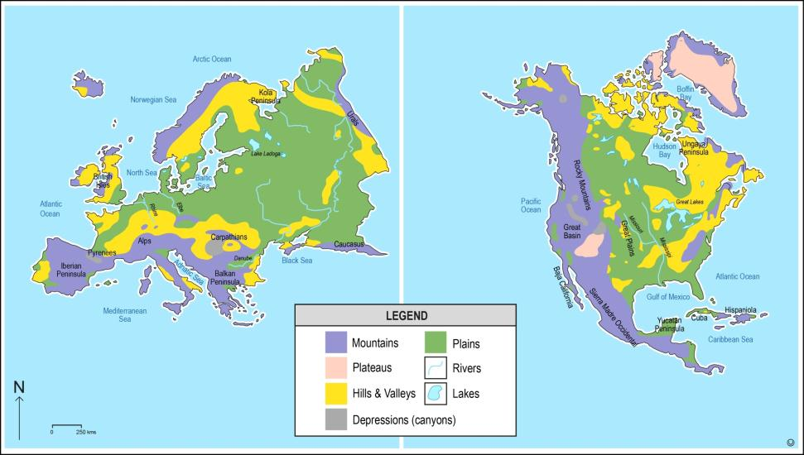

- Use the maps above to identify and describe the spatial distribution of the landforms of Europe and North America, listed in the table below. Use the word bank to help complete the table. Select the words carefully as not every word is needed and you may need to use the same word more than once.
Use the information, in the diagram below, to assist you.
Landform Type | Europe | North America
 | Distribution pattern | Distribution pattern
Plains
Mountains
Lakes

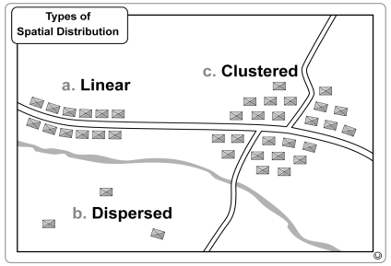
Word Bank
Distribution pattern
Linear (line)
Clustered (grouped)
Dispersed (scattered)

