Balloon Balance Science Investigation
Question: Does gas have _________?
Materials:  - 2 Balloons  - Equal length string x 2 pieces  - 1 piece longer string  - Ruler  - Tape  - Pin | 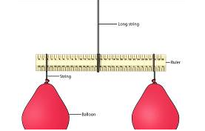
Method:
- Blow up both balloons to the same size;
- Attach the longer string to the middle ruler using tape;
- Tie the other string to each of the balloons;
- Attach one balloon to each side of the ruler;
- Hold the longer string attached to ruler – they should be balancing;
- Push the pin into ONE of the balloons (do not pop!)
- Observe what happens as the balloon loses air;
Prediction:
I think that........because……
Observations:
(what happened?...why?)
Fair Test:
(What would happen if I filled the balloons with two different types of gas – would this be fair?)

